
HOUSING PRICE PREDICTION
USING LINEAR REGRESSION
Department of Computer Science
MNS University of Agriculture
Artificial Intelligence Project Report
Program: BSIT
Semester: 5th (C)
Group No: 02
Name | Registration No.
Maryam Khan | 2023-UAM-2268
Muneeb Ur Rahman | 2023-UAM-2228
Arslan Zafar | 2023-UAM-2225
Sadaf Javed | 2023-UAM-2234
Bushra Kanwal | 2023-UAM-2238
Afifa Shafiq | 2023-UAM-2271
Submitted To: Ms. Sania Ayoub

Abstract
House price prediction is a common regression problem where the goal is to estimate property values based on measurable house attributes. In this project, we build a Linear Regression model using the Kaggle House Prices dataset to predict SalePrice. A set of strong and easy-to-interpret numerical features (living area, overall quality, bedrooms, bathrooms, and garage capacity) is selected to keep the solution simple while maintaining predictive power. The model is trained, tested, and analyzed using evaluation metrics and diagnostic graphs (actual vs predicted and residuals) to understand performance and errors.

Table of Contents
1. Introduction
2. Dataset Overview
3. Feature Selection Rationale
4. Data Preparation
5. Model Design (Linear Regression)
6. Experimental Setup and Evaluation Metrics
7. Results and Discussion
8. Conclusion and Future Work
9. Project Repository
10.References
Appendix A: Training Script (train.py)

1. Introduction
Accurate house price estimation supports decision-making for buyers, sellers, and real-estate businesses. Traditional pricing approaches rely on manual judgment and can be inconsistent. Machine learning offers a systematic way to learn relationships from historical sales data and produce reliable predictions. This report documents the complete workflow of building a regression model for predicting house prices using selected numerical features.
Problem Statement: Predict the sale price (SalePrice) of a house based on measurable attributes available in the dataset.
Project Objectives:
- Use a real-world dataset and perform structured preprocessing.
- Select strong, interpretable features for prediction.
- Train a Linear Regression model and evaluate its performance.
- Visualize model behavior using diagnostic graphs.
- Prepare a clean GitHub repository with code and documentation.

2. Dataset Overview
Dataset Source: Kaggle – House Prices: Advanced Regression Techniques. The dataset contains detailed attributes for residential homes and their sale prices.
Dataset Shape: 1460 rows and 81 columns.
Target Variable: SalePrice (house sale price).
Summary statistics of SalePrice:
Statistic | Value
Count | 1460
Mean | 180,921.20
Median | 163,000.00
Std | 79,442.50
Min | 34,900.00
Max | 755,000.00
Skewness | 1.88

Missing values in selected columns (0 is ideal):
Column | Missing Count
GrLivArea | 0
OverallQual | 0
BedroomAbvGr | 0
FullBath | 0
GarageCars | 0
SalePrice | 0
Distribution of SalePrice:
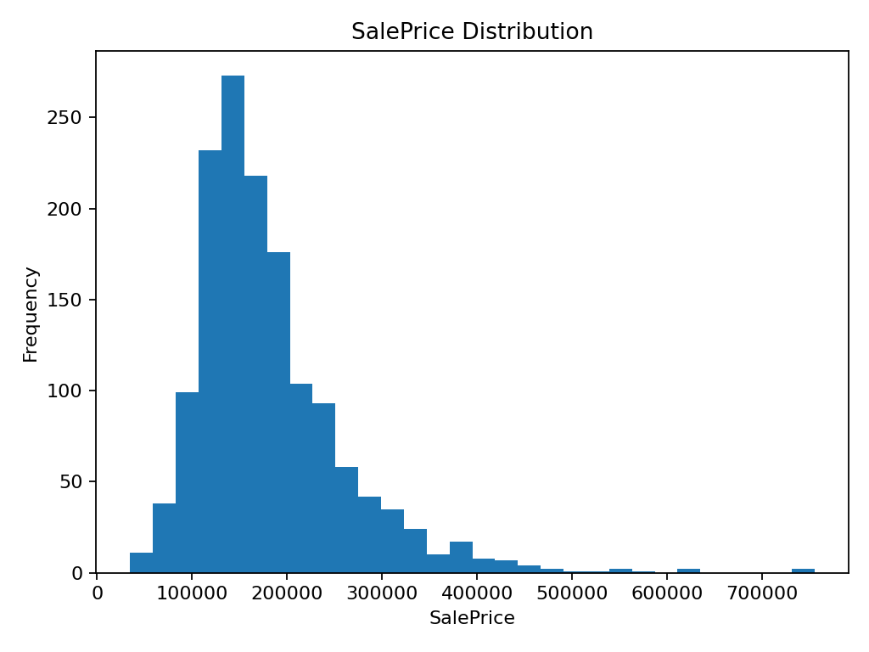

3. Feature Selection Rationale
To keep the solution simple and explainable while still achieving strong results, we used a small set of numerical features that are known to influence house prices.
Selected Features and Reasons:
Feature | Why it matters
GrLivArea | Represents the primary living area; larger area generally increases price.
OverallQual | Captures overall material and finish quality; higher quality tends to increase price.
BedroomAbvGr | Number of bedrooms; contributes to usability and value.
FullBath | Number of full bathrooms; additional bathrooms typically increase price.
GarageCars | Garage capacity; convenient facilities add value.

4. Data Preparation
The dataset is loaded using pandas. We directly use the selected numerical columns. For this simplified baseline, missing values in the chosen features are checked and found to be minimal/none in most cases (see missing values table). The data is split into training and testing sets to evaluate how well the model generalizes to unseen data.
Train-Test Split: 80% training and 20% testing (random_state=42 for reproducibility).

5. Model Design (Linear Regression)
Linear Regression models the relationship between the input features and the target as a linear combination of feature values. It is widely used for regression tasks due to its simplicity, interpretability, and strong baseline performance.
Learned model form:
SalePrice = intercept + Σ (coefficient_i × feature_i)
Estimated coefficients (trained on the training set):
Feature | Coefficient
OverallQual | 25,111.1471
GarageCars | 21,069.6146
FullBath | 1,927.1100
GrLivArea | 56.4430
BedroomAbvGr | -9,149.2566
Intercept | -72,622.6863

6. Experimental Setup and Evaluation Metrics
We evaluate the model on the held-out test set using standard regression metrics. We also compute 5-fold cross-validation RMSE to estimate performance stability.
Metrics used:
- RMSE (Root Mean Squared Error): penalizes large errors more strongly.
- MAE (Mean Absolute Error): average absolute difference between actual and predicted prices.
- R² Score: proportion of variance in SalePrice explained by the model.
Test Set Results (20% hold-out):
Metric | Value
RMSE | 41,832.24
MAE | 27,814.54
R² | 0.77
Cross-Validation (5-Fold) RMSE:
Mean RMSE | Std RMSE
40,567.68 | 6,132.64

7. Results and Discussion
The scatter plot (Actual vs Predicted) provides an intuitive understanding of model accuracy. If predictions are accurate, points lie close to a diagonal trend. The residual plot helps detect systematic errors; residuals randomly scattered around zero indicate a reasonable fit.
Actual vs Predicted Plot:
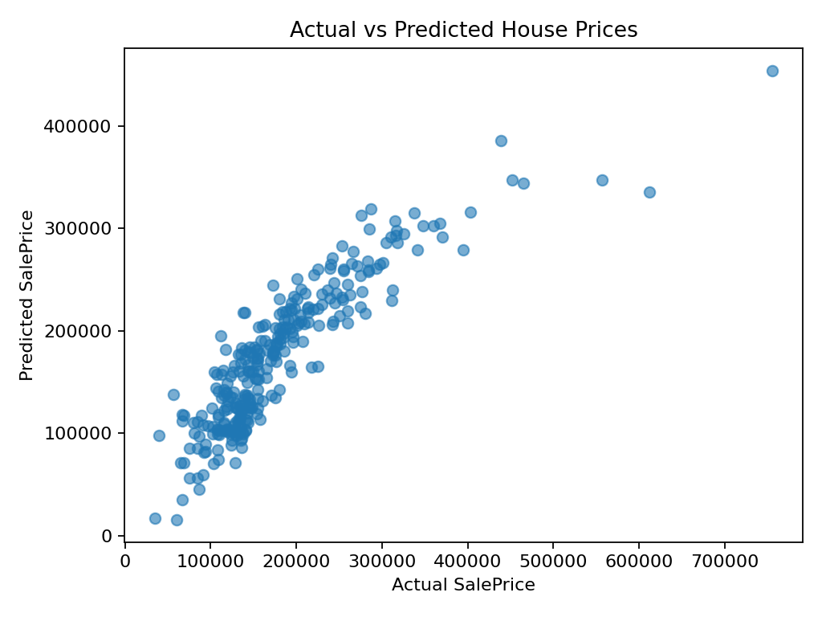

Residual Plot:
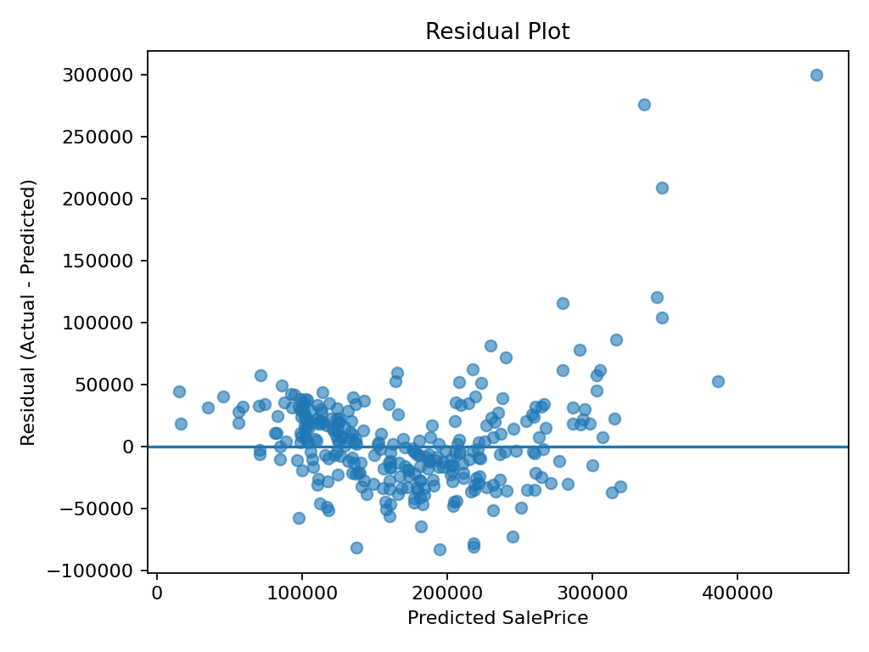
Discussion:
- The model performs as a strong baseline because the selected features capture size and quality.
- Errors may occur due to factors not included in the simplified feature set (e.g., neighborhood, year built, condition, remodeling, and other categorical influences).
- Further improvements can be achieved by including more features and using regularized or non-linear models.

8. Conclusion and Future Work
This project demonstrates a complete, reproducible workflow for house price prediction using Linear Regression. With a small set of carefully chosen features, the model achieves reasonable performance and remains easy to explain during presentation or viva.
Future improvements may include:
- Including additional numerical and categorical features with proper encoding.
- Applying regularization (Ridge/Lasso) to reduce overfitting.
- Trying non-linear models such as Random Forest or Gradient Boosting.
- Using log-transformation of SalePrice to handle skewness and improve error distribution.

9. Project Repository
The complete source code, dataset, project report, and presentation files for this project
are maintained in a public GitHub repository. The repository ensures transparency,
reproducibility, and easy access to all project resources.

GitHub Repository Link:

https://github.com/Muneebworks/Housing-Price-Prediction

10. References
Kaggle: House Prices – Advanced Regression Techniques (dataset).
scikit-learn documentation for LinearRegression and evaluation metrics.
pandas documentation for data manipulation.

Appendix A: Training Script (train.py)
import pandas as pd
import matplotlib.pyplot as plt
from sklearn.model_selection import train_test_split
from sklearn.linear_model import LinearRegression
data = pd.read_csv("train.csv")
X = data[["GrLivArea","OverallQual","BedroomAbvGr","FullBath","GarageCars"]]
y = data["SalePrice"]
X_train, X_test, y_train, y_test = train_test_split(X, y, test_size=0.2, random_state=42)
model = LinearRegression()
model.fit(X_train, y_train)
predictions = model.predict(X_test)
plt.figure(figsize=(8, 6))
plt.scatter(y_test, predictions, alpha=0.6)
plt.xlabel("Actual House Price")
plt.ylabel("Predicted House Price")
plt.title("House Price Prediction using Linear Regression")
plt.show()

